
MATHS METHODS 3 & 4
TRIAL EXAMINATION 1
SOLUTIONS
2006

___________________________________________________________________________

Question 1

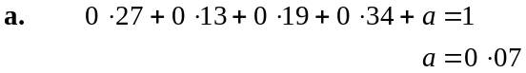
(1 mark)

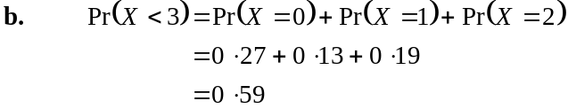
(1 mark)

- 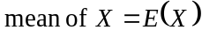
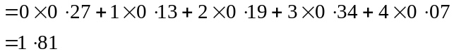
(1 mark)
If an incorrect value resulting from part a. is used and the resulting answer is correct the mark should be awarded.

- The median is 2.
The median is the middle score. Half the scores are above it and half below.
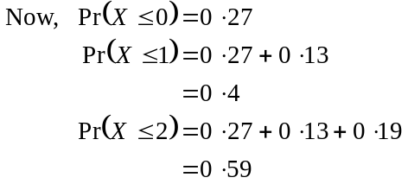
So the median of X is 2 since half the scores are below it.
(1 mark)

Question 2

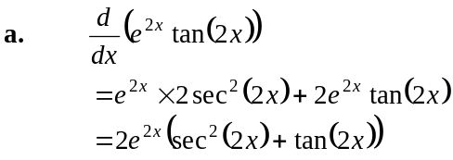
(1 mark)
(1 mark)

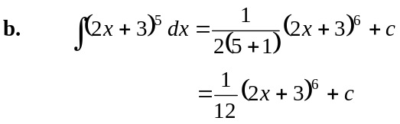
(1 mark)

Question 3

a. 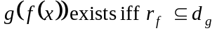
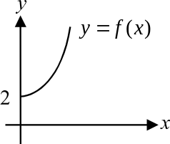
Now, 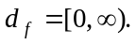
A quick sketch enables you to find 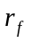.
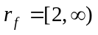 (1 mark)
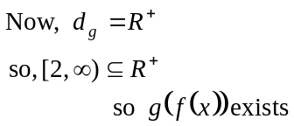
(1 mark)
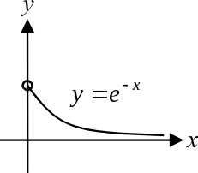
  - 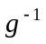 exists iff the graph of 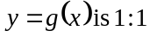.

Again, a quick sketch tells us whether g is
a 1:1 function.

Since any horizontal line can be drawn on the graph so that it crosses the function only once, it is a 1:1 function.
So exists.
(1 mark)

  - Let 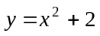
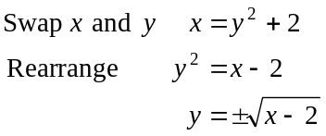
(1 mark)
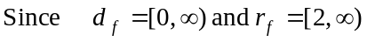 from part a.,
then 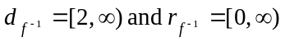
So the rule for 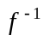 is 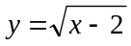.
Note that we reject 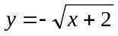 because the range of contains only positive values. (1 mark)
Also 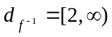. (1 mark)

Question 4

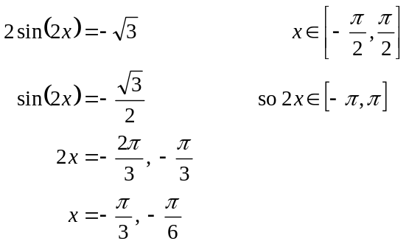
(1 mark)
(1 mark)
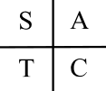
(1 mark)

Question 5

- 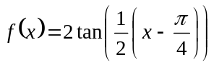
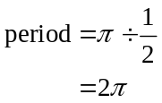
(1 mark)

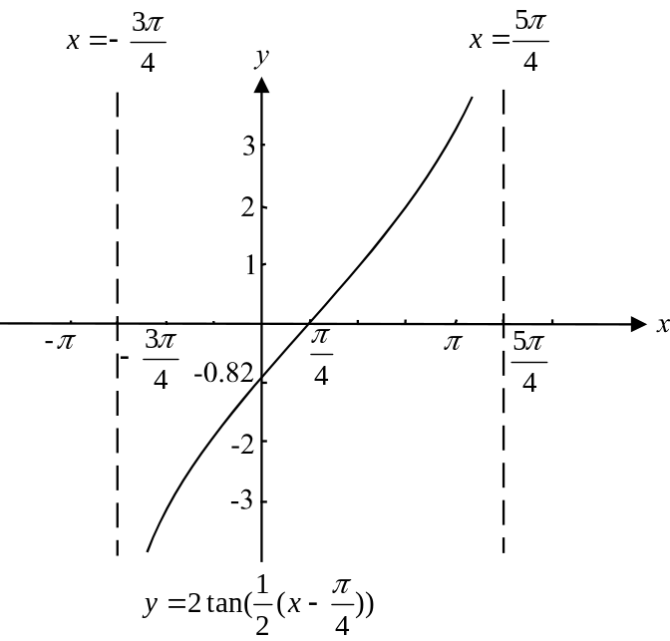

(1 mark)
The period is 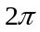 and the graph is translated 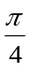 units right.
The asymptotes therefore occur at 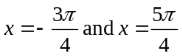. (1 mark)
The x-intercept occurs at 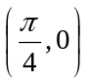.
The y-intercept occurs when
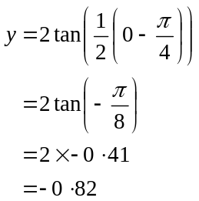
(given in question)
The y-intercept occurs at 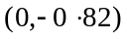.
(1 mark) for intercepts
Question 6

Sketch a quick diagram.

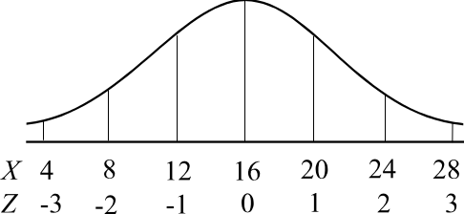

- The normal curve is symmetrical around the mean.
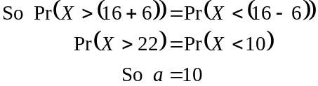
(1 mark)

- Method 1
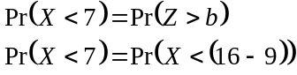
Since 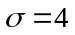, 9 below the mean represents 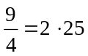 standard deviations below the mean.
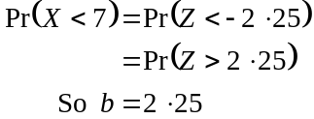
(1 mark)

Method 2
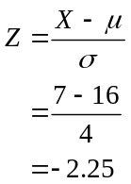
(1 mark)

Question 7
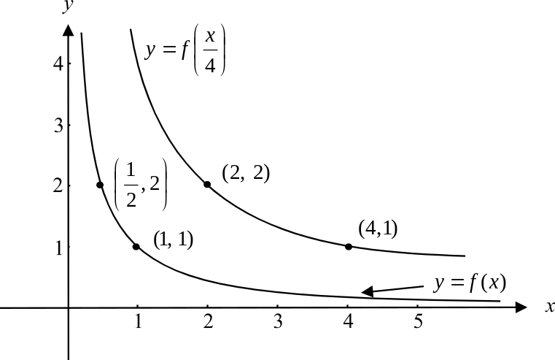

(1 mark) (correct shape) (1 mark) (showing coordinates of 2 correct points)

b. The graph of 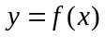 has been dilated by a factor of 4 parallel to the x-axis or in the x
direction or away from the y –axis. (1 mark)
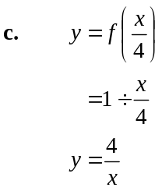
(1 mark)

Question 8
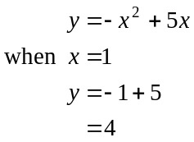
Point of tangency is 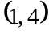. (1 mark)
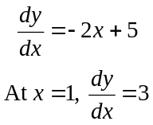
(1 mark)
The equation of the tangent at 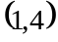 is
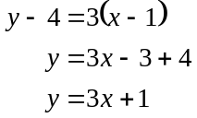
(1 mark)
This tangent crosses the x-axis when 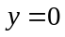
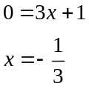
So 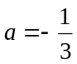 (1 mark)

Question 9

- The function f crosses the x-axis at so one linear factor is 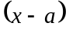.
The function f touches the x-axis at so there is a repeated linear factor of 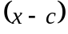.
The three linear factors are 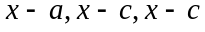.
(1 mark)

- 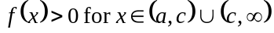 or 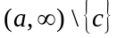
(1 mark)

- 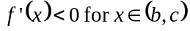
(1 mark)

Question 10

- The probability that a team does a bad job when the previous day’s team did a good job is 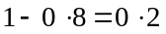.
(1 mark)

- This is a multi-stage event; that is, it involves what happens on Thursday and then on Friday.
A tree diagram is useful.
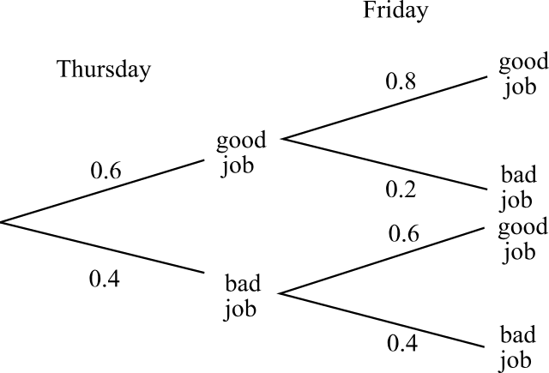

(1 mark)
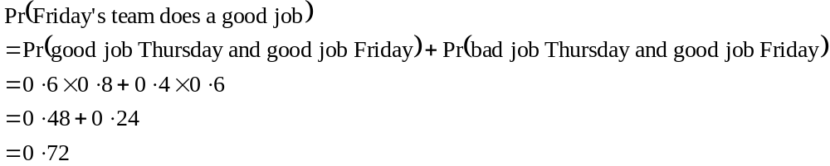
(1 mark)
(1 mark)

Question 11

Sketch the graph.
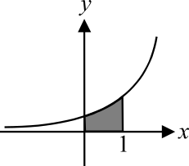

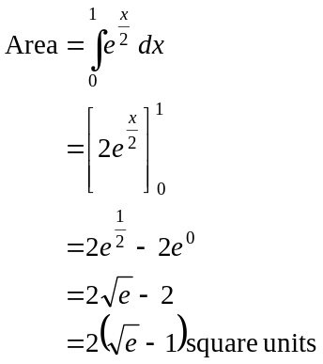
(1 mark)
(1 mark)
(1 mark)

Total 40 marks

